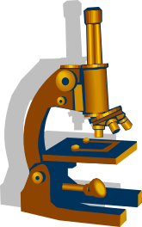
Cells
Put these sentences back together.

1. are one cells All made organisms of more up or.
____________________________________________________________________

2. units in things are of function living Cells the structure and basic.
_____________________________________________________________________
_____________________________________________________________________

3. living are division New produced the other by cells of cells.
_____________________________________________________________________

4. plant nucleus have animal Both and cells a.
_____________________________________________________________________

5. cytoplasm have Plant both animal and cells.
_____________________________________________________________________

6. both what goes Animal to membrane control comes and cells plant and have cell a.
______________________________________________________________________
______________________________________________________________________

7. give have cells them Plant a wall to cell strength.
______________________________________________________________________

8. in make cells Chloroplasts are food to plant used.
_______________________________________________________________________

9. large Plant contain cells vacuole a.
_______________________________________________________________________

10. observe used Microscopes to are cells.
_______________________________________________________________________

11. appearance cells size in vary shape Although purpose and they keep all alive us.
_______________________________________________________________________
_______________________________________________________________________

12. years a Over Hooke tiny piece ‘cell’ ago scientist first blocks Robert cork describe
building the 300 term used to of the observed a in.
_______________________________________________________________________
_______________________________________________________________________
_______________________________________________________________________

